LED Brightness Control System using LDR

Report submitted by

CB.EN.U4ECE21010 Divit G
CB.EN.U4ECE21039 Madhan Kumar R M
CB.EN.U4CCE21040 Raagul T S
CB.EN.U4CCE21046 S Ravindran

in partial fulfillment of the requirements for the course
19ECE384 –Open Lab


Department of Electronics and Communication Engineering,
Amrita School of Engineering,
Amrita Vishwa Vidyapeetham, Coimbatore – 641112

June 2024

- Motivation: We chose to develop a brightness control system using an LDR to enhance energy efficiency and automation. Traditional lighting systems often waste energy by operating at full brightness regardless of ambient light conditions. Our system adjusts LED brightness based on the surrounding light, reducing energy consumption and extending the lifespan of lighting components. This project also aims to increase convenience by automating light control, thus eliminating the need for manual adjustments. We were inspired to tackle this problem as part of the Smart India Hackathon under the smart automation category, demonstrating a practical and cost-effective solution for smart lighting.
- Problem Statement: The project is to develop a brightness control system utilizing an LDR sensor to regulate LED brightness based on ambient light conditions. The system aims to achieve energy efficiency, automation, and cost-effectiveness without relying on a microcontroller. Additionally, a 7-segment display will be integrated to show the atmosphere brightness level.
Design Specifications:
- The system should not use a microcontroller.
- The system should be cost-effective.
- The system should be easy to maintain.
- Integrate a 7-segment display to show the atmosphere brightness level.
- Use a potentiometer to precisely adjust the LED brightness according to the
ambient light.

- Design Procedure: Our project consist of six stages of circuit which are interconnected to form the brightness control circuit.

LDR Circuit
Voltage Divider circuit
Comparator Circuit
Voltage Divider circuit

7 Segment Display circuit
LED connection circuit
Dimmer circuit

Voltage Divider Circuit: To obtain specific voltages (50mV, 75mV, 160mV, and 5V) from a 9V power supply.Components used here is Resistors.
LDR Circuit: To detect changes in ambient light intensity using an LDR. The voltage across the LDR will vary based on ambient light levels.This varying voltage serves as the input signal for the comparator circuit.
Components used here is Resistors (10kΩ, 1kΩ),LDR sensor ,op-amp (LM324).
Comparator Circuit: To compare the LDR output with predefined threshold voltages (75mV and 160mV).Op-amp is configured as comparators, setting 75mV as the lower threshold and 160mV as the upper threshold. When the LDR output falls below 75mV, the comparator output goes high, indicating a dark environment. When the LDR output exceeds 160mV, the comparator output goes low, indicating a bright environment. Intermediate values indicate a partially bright environment.
Components used here is Op-amp (LM324).
7-Segment Display: To display the ambient light level as 'b' for bright, 'p' for partially bright, and 'd' for dark.
Component used here is common cathode seven segment display,OR gate (IC7432) , NOT gate (IC7404).
Dimmer Circuit: To adjust the LED brightness by generating a specific duty cycle.
Use a pulse-width modulation (PWM) circuit to create a variable duty cycle signal.
The duty cycle determines the average power delivered to the LED, controlling its brightness.
Component used here is op-amp (LM324) , resistors (10k,56k,220Ω) and capacitor (100nf).
LED Connection Circuit: To control the LED brightness based on the comparator outputs. Three different outputs are expected:
-Full brightness when the lower threshold comparator output is high (logic 1).
-LED off when the higher threshold comparator output is high (logic 1).
-Partial brightness when both comparators output low (logic 0) and a constant square pulse is fed to the LED
Components used here is An LED , OR gate (IC7432).

- Budget:
PRODUCT NAME | SPECIFICATION | QUANTITY | PRICE (Rs)/AVAILABLE IN LAB
Op-Amp | LM324 | 2 | 70
LDR | NORP12 | 1 | 10
Or gate | IC7432 | 1 | Avaiable in lab
Not gate | IC7404 | 1 | Available in lab
Potentiometer | 100k | 1 | Available in lab
7segment dispaly | Common cathode | 1 | Available in lab
LED |  | 1 | 5
Capacitor | 1uF | 1 | Avaiable in lab
Resistors | 100Ω,1k,220Ω,330Ω | 4,2,2,3 | Available in lab
Resistors | 10k,12k,18k,5.6k,56k | Each 1 | Available in lab
Bread board |  | 1 | Available in lab
Connecting wires |  | As req. | Available in lab

- Circuit Diagram / Board Layout / Schematic:
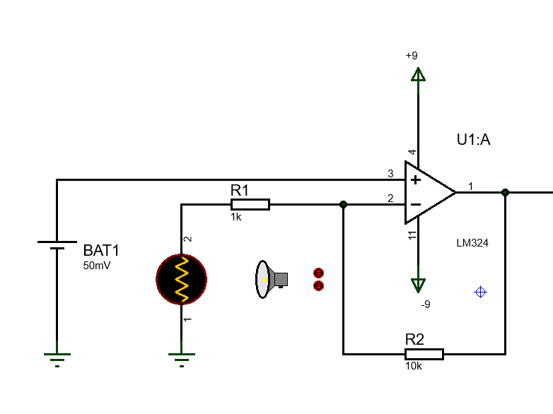
Figure 1 LDR circuit
LDR changes its resistance according to the level of the light. In an non inverting amplifier, since the Gain G = 1+(Rf/Rin), if Rin keeps changing then G changes and the output voltage Vo changes.

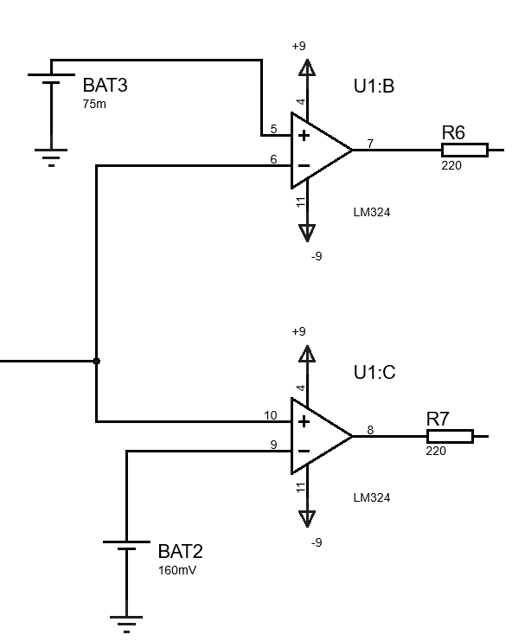
Figure 2 Comparator circuit
The output voltage Vo is fed into a window comparator circuit. Thus we can divide the voltage obtained into 3 cases – Bright, Dark and partially bright.

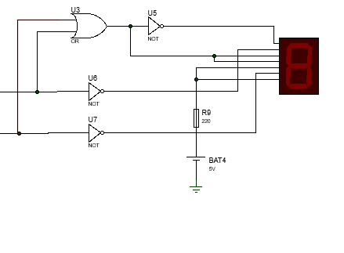
Figure 3 7 segment display circuit
This circuit obtains the values from the window comparator circuit and displays a letter for each case.
a=(x+y ) ̅ b=y ̅ c = x+y
d = x+y g = 1 e = 1 f=x ̅

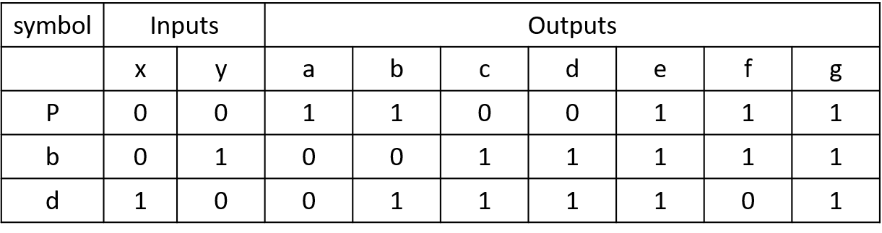
Depending on values of x and y Partial brightness(P), Bright(b) and Dark(d) are displayed.

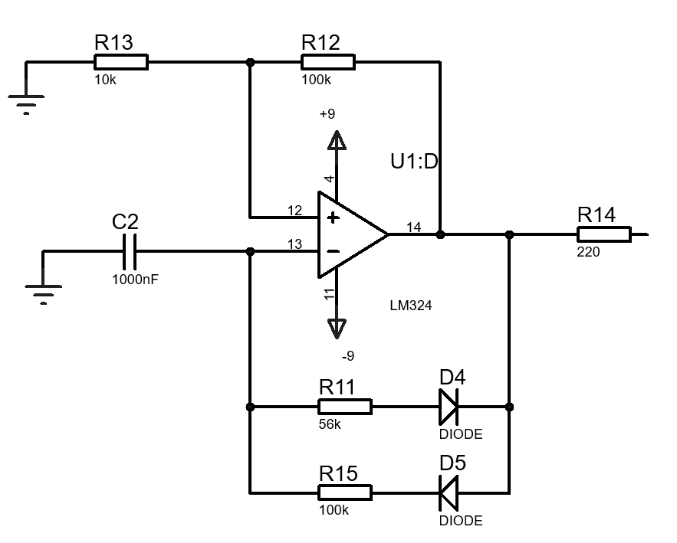
Figure 4 Dimming circuit
The dimmer circuit is used to provide a square wave to the LED. The dimming of the LED can be adjusted by adjusting the duty cycle of th circuit. In order to achieve this we use 2 diodes
- Simulation Results / Discussion:
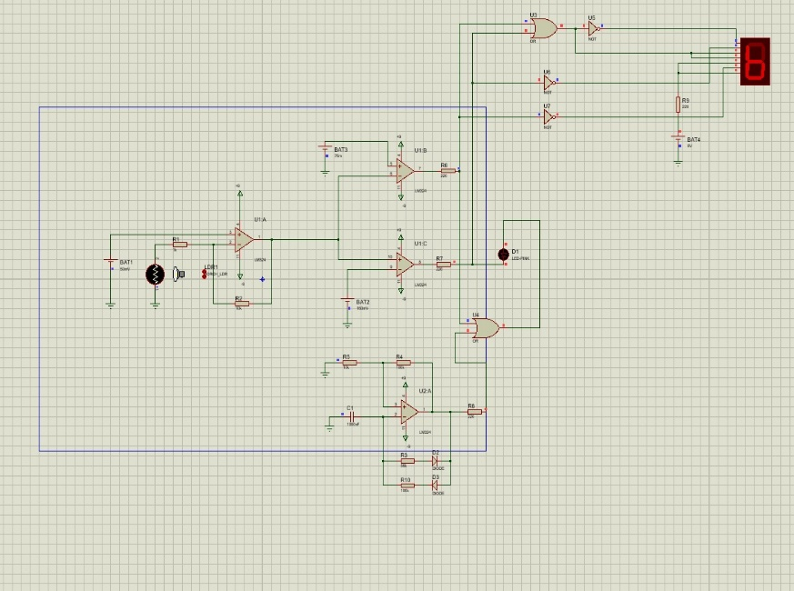
Figure 5 LDR detects light, LED is off, ‘b’ is displayed
Case 1: When LDR is hit with light, The LED is turned off to conserve power. ‘b’ is displayed to indicate full brightness.

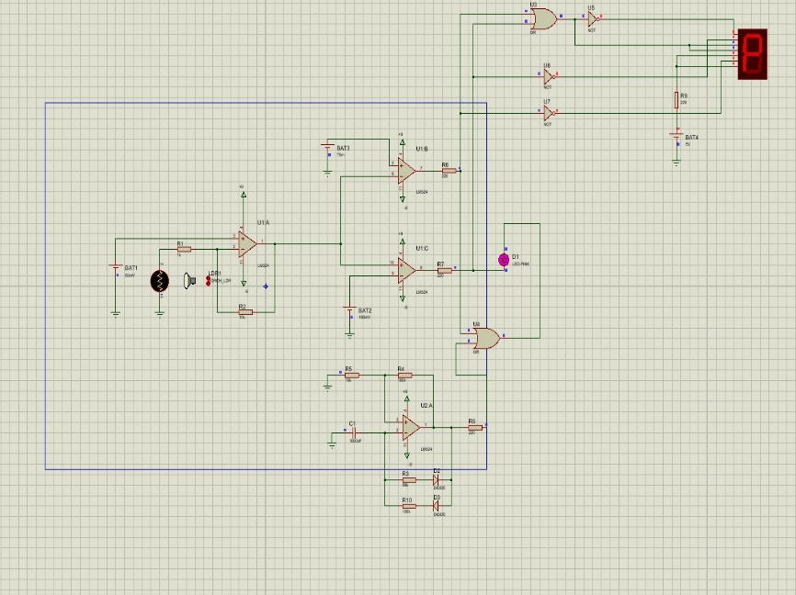
Figure 6 LDR detects partial light, LED partially glows, ‘P’ is displayed
Case 2: When LDR is hit with limited light, The LED is dimmed to conserve power. ‘P’ is displayed to indicate partial brightness.

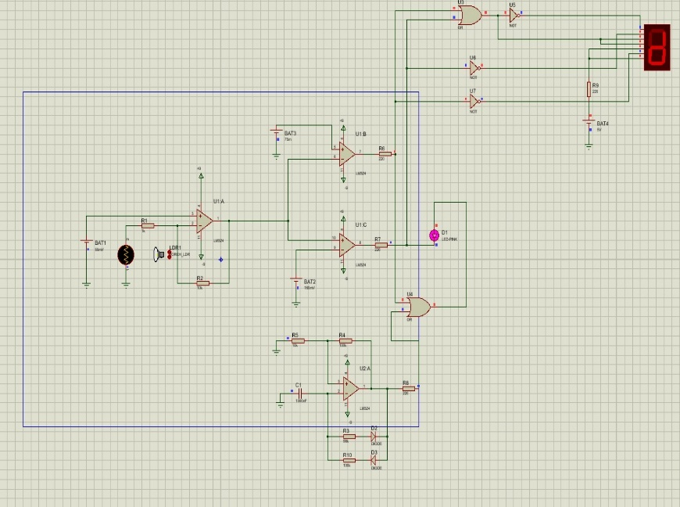
Figure 7 LDR detects NO light, LED glows fully, ‘d’ is displayed
Case 3: When LDR doesn’t detect any light (or) when very less light falls on the LDR, The LED is turned on. ‘d’ is displayed to darkness.

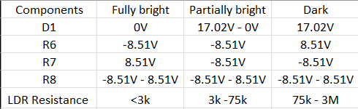
Figure 8 Simulation result values

The values of the LDR resistances are adjusted based on the given graph.
When the voltage is greater than 0V, The LED glows. Therefore, for Fully bright conditions the LED is off. But for dark condition, LED turns on. For partial bright conditions, The LED fluctuates between HIGH and LOW.
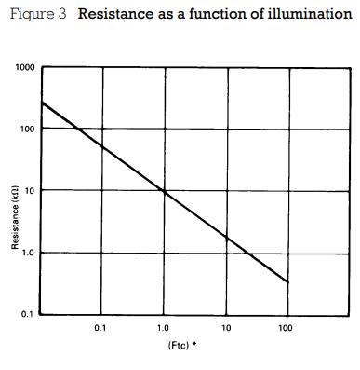
Figure 9 Resistance Luminescence relation

- Implementation / Prototytping results:
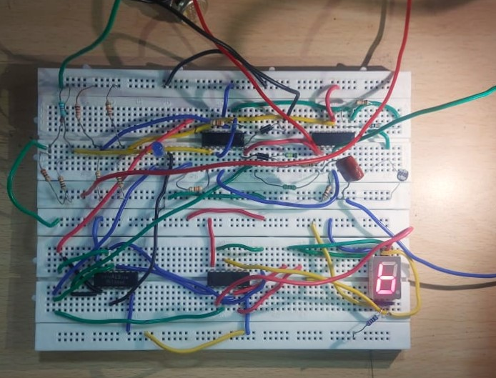
Fig. 1 LDR detects light, LED is off, ‘b’ is displayed

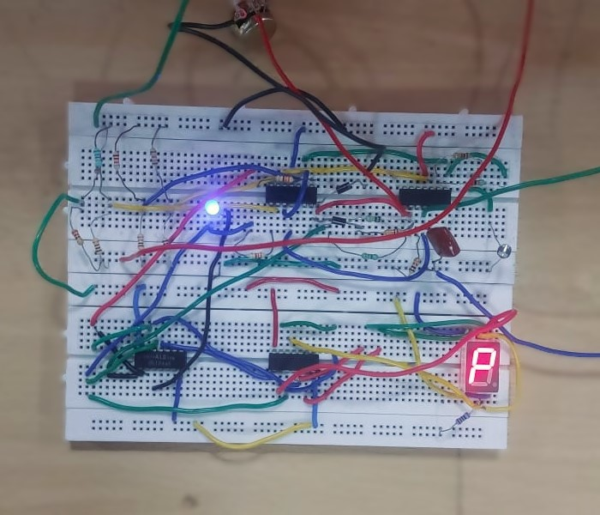

Fig. 2 LDR detects partial light, LED partially glows, ‘P’ is displayed

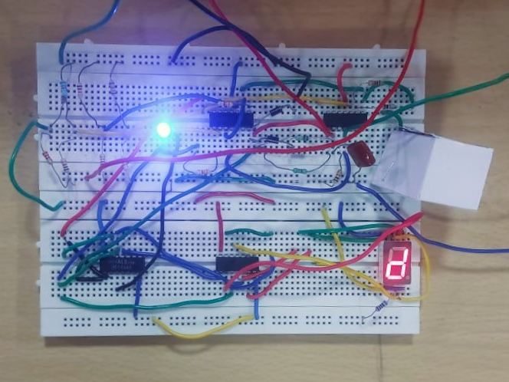
Fig. 3 LDR detects NO light, LED glows fully, ‘d’ is displayed

- Discussion & Conclusions: The brightness control system is achieved using an LDR module. While this works under normal conditions, the user has to introduce a means to modify its parameters under extreme light conditions.

